Lab: Asynchronous Programming
The following tasks do not have tests in the Judge system. They are for practice.
Working with Remote Data
For the solution of some of the following tasks, you will need to use an up-to-date version of the local REST service, provided in the lesson’s resources archive. You can read the documentation here.

XHR (XmlHttpRequest)
Your task is to write a JS function that loads a github repository asynchronously with AJAX. You should create an instance of XmlHttpRequest and attach an onreadystatechange event to it. (An EventHandler that is called whenever the readyState attribute changes). Obtain the data by making a GET request to the following URL: https://api.github.com/users/testnakov/repos. In your event handler, when the readyState attribute reaches a value of 4 (it is ready), replace the text content of a div element with id "res" with the value of the responseText property of the request. Do not format the response in any way.
More on XmlHttpRequest.open()

Examples
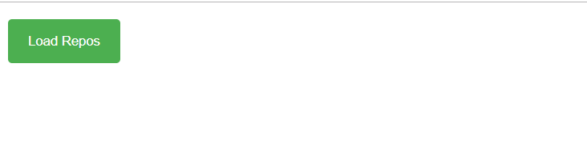
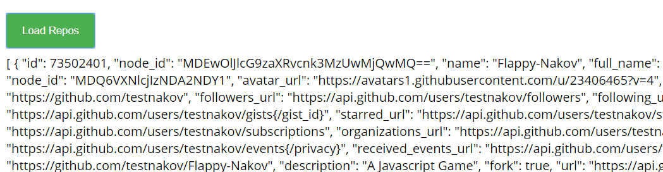

Github Repos
Your task is to write a JS function that executes an AJAX request with Fetch API and loads all user github repositories by a given username (taken from an input field with id "username") into a list (each repository as a list-item) with id "repos". Use the properties full_name and html_url of the returned objects to create a link to each repo’s GitHub page. If an error occurs (like 404 “Not Found”), append to the list a list-item with text the current instead. Clear the contents of the list before any new content is appended. See the highlighted lines of the skeleton for formatting details of each list item.

Examples
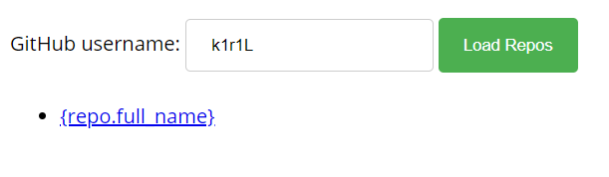
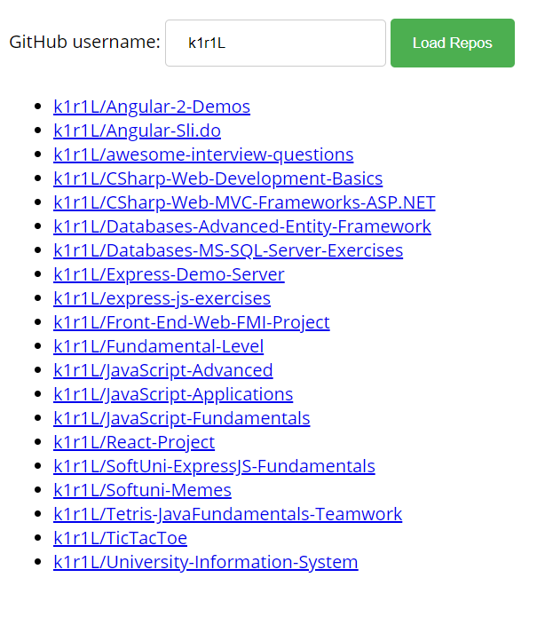

Github Commits
Write a JS program that loads all commit messages and their authors from a github repository using a given HTML.
The loadCommits() function should get the username and repository from the HTML textboxes with IDs "username" and "repo" and make a GET request to the Github API:
https://api.github.com/repos/<username>/<repository>/commits
Swap <username> and <repository> with the ones from the HTML:
- In case of success, for each entry add a list item (<li>) in the unordered list (<ul>) with id "commits" with text in the following format:
"<commit.author.name>: <commit.message>"
- In case of an error, add a single list item (<li>) with text in the following format:
"Error: <error.status> (Not Found)"

Screenshots:
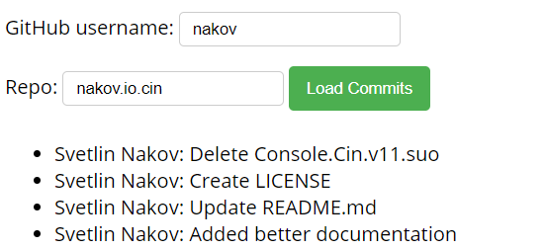
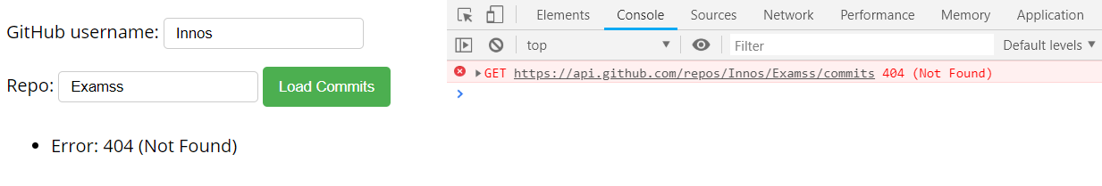

Cookbook – Part 1
The resources for this task are available in the following GitHub repository:
https://github.com/viktorpts/js-apps-workshop
You may check-out the repository or download the files via the green button labeled "Code" in the upper-right corner. Use the files located in lesson-02/base to begin the task. Before starting, make sure you have the most recent version of the repository. To see the solution, check the files inside lesson-02/finished.
Write a JS program that loads all recipies from the provided local server. You are provided with skeleton (HTML & CSS) for this task, also with server, which you will use as localhost. You will be able to load from the server "database" the needed recipies and other details.

Load all recipies
When the app is started, you need to load all the recipies from the server:
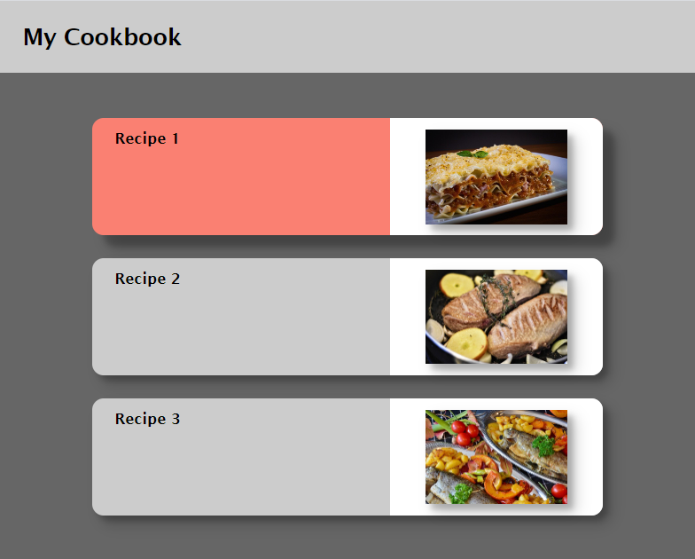
You have to make "GET" request to the server on this URL: http://localhost:3030/jsonstore/cookbook/recipes

Load selected recipe
By clicking on a card with recipe you need to make a "GET" request to the server, and toggle the information only for the selected recipe.
The URL for the details is: http://localhost:3030/jsonstore/cookbook/details/:id
Where ":id" is the id of the selected recipe.
